**Salinity: River Plumes and Estuaries**

**The Wavetable Project**

How do rivers and oceans mix? Why do river estuaries deposit muddy/silty water for thousands of square kilometers over the ocean surface, but hardly ever mix? How do they interact? Well, to answer this, we need to learn about river plumes!

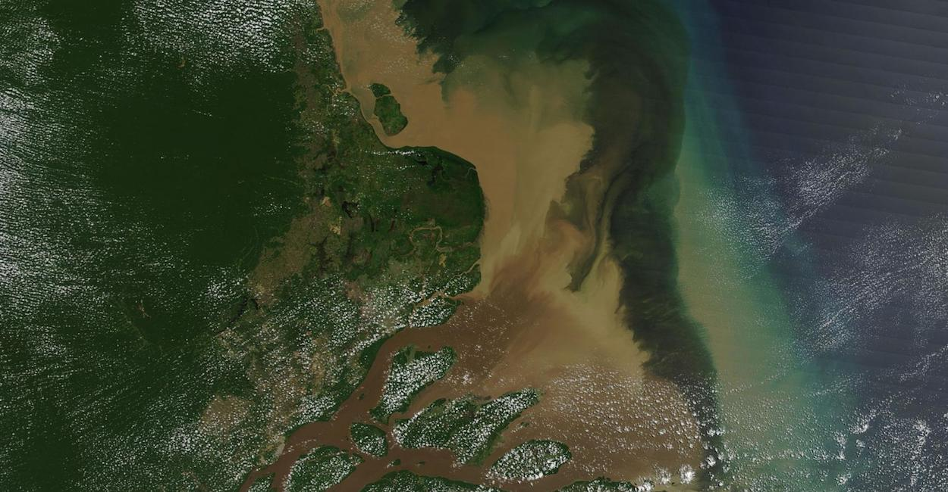

**Figure 1.** Amazon river plume pictured in 2020 shows the distribution of sediments into the ocean [1].

The oceans are saltwater bodies, while many rivers are freshwater. When freshwater rivers are deposited into the oceans, they form distinct shapes and hug coastlines in a process known as river discharge. The area where this interaction occurs is called a **river plume**! In this lab, we will discuss and experiment with the different types of plumes, how they occur and why they are important for interactions between the land and sea.

**Before you begin, you will need:**

1. Wavetable
   1. With a RECTANGULAR tank
2. Food dye
3. Salt
4. Extra cup for dyed, non-salt water

**Safety:**

1. Keep all exposed wires away from the water tank
2. Keep all long hair tied back and away from any spinning parts of the setup
3. **Instead of using normal water in the tank, we will use a saline solution to mimic the buoyancy difference found in river plumes. To start, fill your tank with water to just below the interior ridge (see examples), and add 5 tablespoons of salt. Mix thoroughly until the salt is completely dissolved.**
4. **To begin this experiment, place your tank filled with SALT water on the wavetable and slowly bring up the speed to set 0.5. Wait for the tank to reach solid-body rotation, which usually takes about 10 minutes.** *Note: for more information on this please refer back to the solid body rotation lab.*

As you can see in Fig 1, river plumes tend to hug coastlines as they distribute sediments and drive coastal currents.These are important processes as they deliver critical nutrients into coastal regions of the oceans. The thin layer of ocean water on top of the ocean can warm the ocean by preventing the upwelling circulation from occurring As discussed in the hurricanes lab, the temperature of the ocean can affect the intensity of hurricanes forming in the region.

River plumes in the world are categorized into many different types. A few examples are swirly plumes, u-turn plumes, and meltwater plumes[1]. As physical oceanographers, Alexander Yankovsky and David Chapman summarized, “The structure of this plume may take a variety of shapes depending on the ambient flow, bottom topography, inflow properties, and wind forcing.” But if we distill the basic features of a plume down, they can be referred to as either a **bottom advected plume** or a **surface advected plume.** The differentiating feature is the stratification of the water in the plume. A bottom advected plume occurs when the water is stratified (or arranged into layers) perpendicular to the surface of the ocean, and a surface advected plume is when the water’s stratification is parallel to the surface. In the case of a bottom advected plume, the freshwater reaches the seafloor, whereas, in a surface advected plume, the freshwater stays on the surface of the ocean.

1. **To simulate the river plume, we will use regular NON SALT water to represent the outflow. To do this, mix 2 cups of water with about 10 droplets of food dye in a separate container. Then, slowly pour about half of this mixture into one of the corners of the tank, whilst it is spinning.**

Watching the feed from the overhead camera, what kind of river plume does the dye seem to create? The dye should hug the edge of the tank, how might this behavior happen in the real world?

|  |
| --- |

If we wanted to create another type of river plume, what variables might we want to change in order to produce another?

|  |
| --- |

*Please read:*

**Bottom Advected Plumes vs Surface Advected Plumes**

When a plume occupies depths along the coast far deeper than that of the estuary it originated from and it displaces entire columns of shelf water (the water near the coast) then it is classed as a bottom advected plume. Their tendencies and behaviors are almost entirely dependent on advection in the lower depths of the plume (ie. at the bottom of the coastal shelf). The maximum depths ever recorded for this class of plume is 200m while the farthest offshore distance is 100km or ~60 miles.

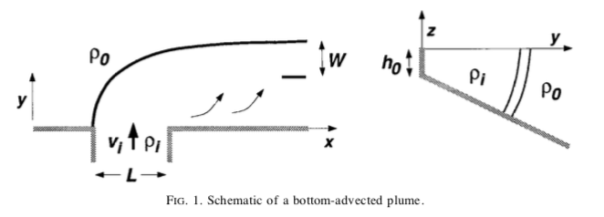

**Figure 2.** Yankovsky and Chapman’s 1997 diagram of the tendencies of *ideal* bottom advected plumes. Left: top-down view where L is the outflowing estuary. Right: side view. [3]

The tendency and shape of a bottom advected plume is summarized in Fig 2, and that shape is derived from three factors.

1. The Coriolis force. This force will push all buoyant (non-saline) flow from the estuary to the right and up the coast.
2. Shelf currents. The intensity and direction of currents hugging the coasts will dictate the length to which the plume will spread as well as its ability to force buoyant water down through advection.
3. The depth of the seafloor. The relative depth between the estuary, the seafloor, and the maximum depth advection can force buoyant water force the plume to either stay near the surface (surface advected plumes) or near the seafloor (bottom advected plumes).
4. **To try and create another type of river plume, we will begin by changing a few of our variables in line with what causes plumes in the real world. These will be the rotation speed (coastal current speed) and the amount of water in the tank (seafloor depth). To do so we must empty our used water, and refill the tank halfway to the max fill line with SALT water. Once your tank is filled, increase the speed to set 0.3 and wait for solid-body rotation to be achieved.**

*Please read:*

While we wait for the water to reach solid-body rotation, let’s begin to think about what factors are the most important in creating different types of river plumes.

Both surface and bottom advected plumes are affected by the Coriolis force, as well as the buoyancy gradient between the estuary and the ocean. Because of this, we will discount these two variables in our explanation as they play little to no role in the difference between the two types of plumes—additionally, how might we simulate these changing factors in the wavetable? Keep this in mind.

This leaves us with **shelf currents and seafloor depth as our two factors**. Shelf currents are important because they increase or decrease the momentum of the plume (depending on the direction of movement) and in doing so make it harder for bottom advection to begin. Fast flowing currents are not what bottom advected plumes need, instead they need calmer water to be able to force the buoyant water down; as a result when fast and powerful currents generally signal a surface advected plume. But there are still the most important factors, and they are depth and distance. In their 1997 study, Yankovsky and Chapman found that if the “depth to which bottom boundary layer processes can move the buoyant discharge” is farther from the estuary than the “extent to which a plume may spread at the surface” then a bottom advected plume will form. Essentially, if the seafloor is as deep as the plume can go, then a bottom advected plume will form. The flip side is true for surface advected plumes.

If the maximum depth of the plume is shallower than the estuary then a surface advected plume will form. This type of plume will spread out radially (in an ideal scenario) and remain on the surface with minimal to no bottom advection. Figure 3 gives an example of this discussed shape.

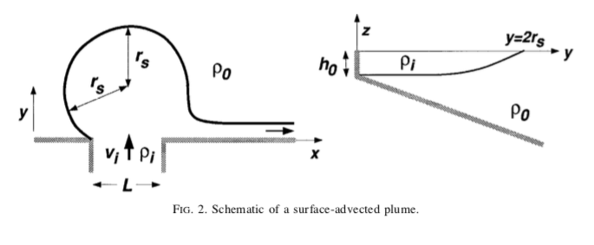

**Fig 3.** From Yankovsky and Chapman, this shows the top and side view of an *ideal* surface advected plume. The key difference from bottom advected plumes is their tendency to spread on the surface of the ocean rather than beneath. [3]

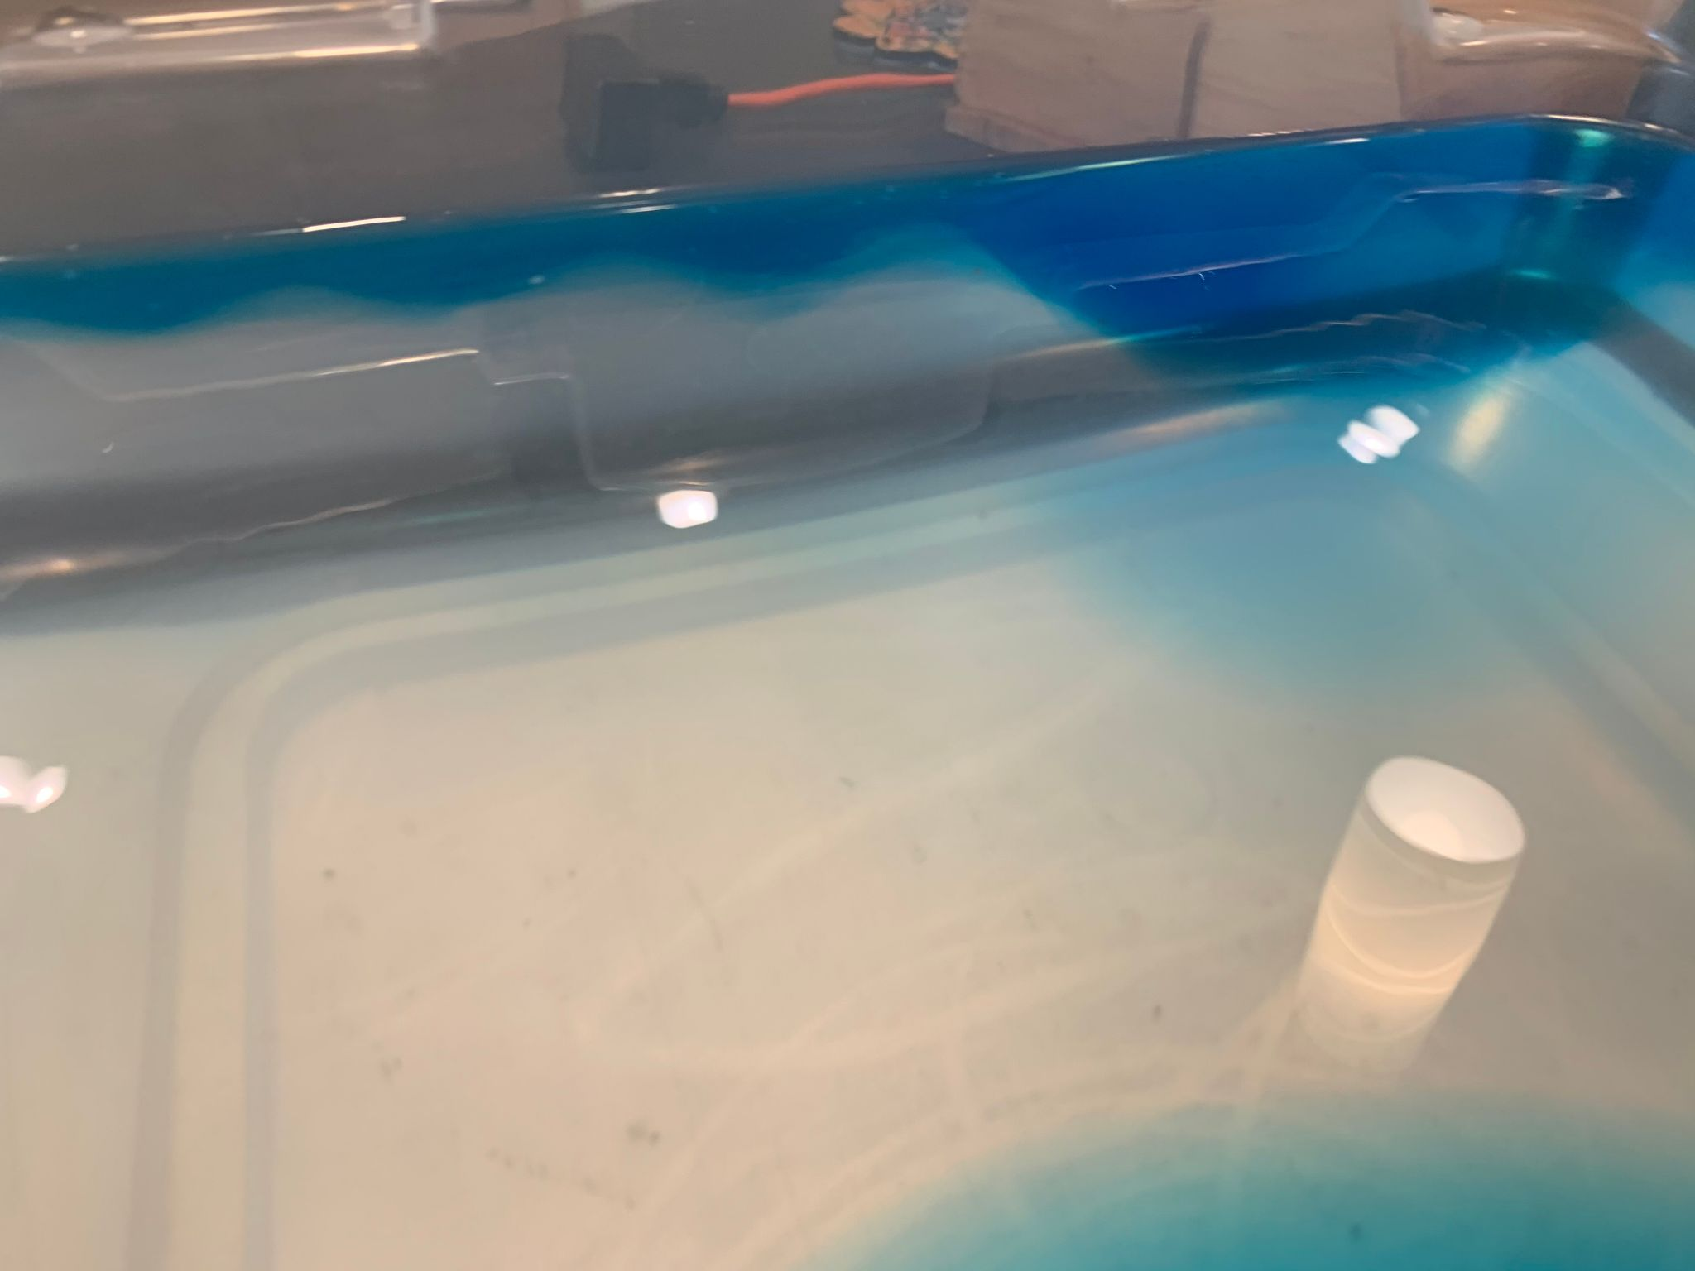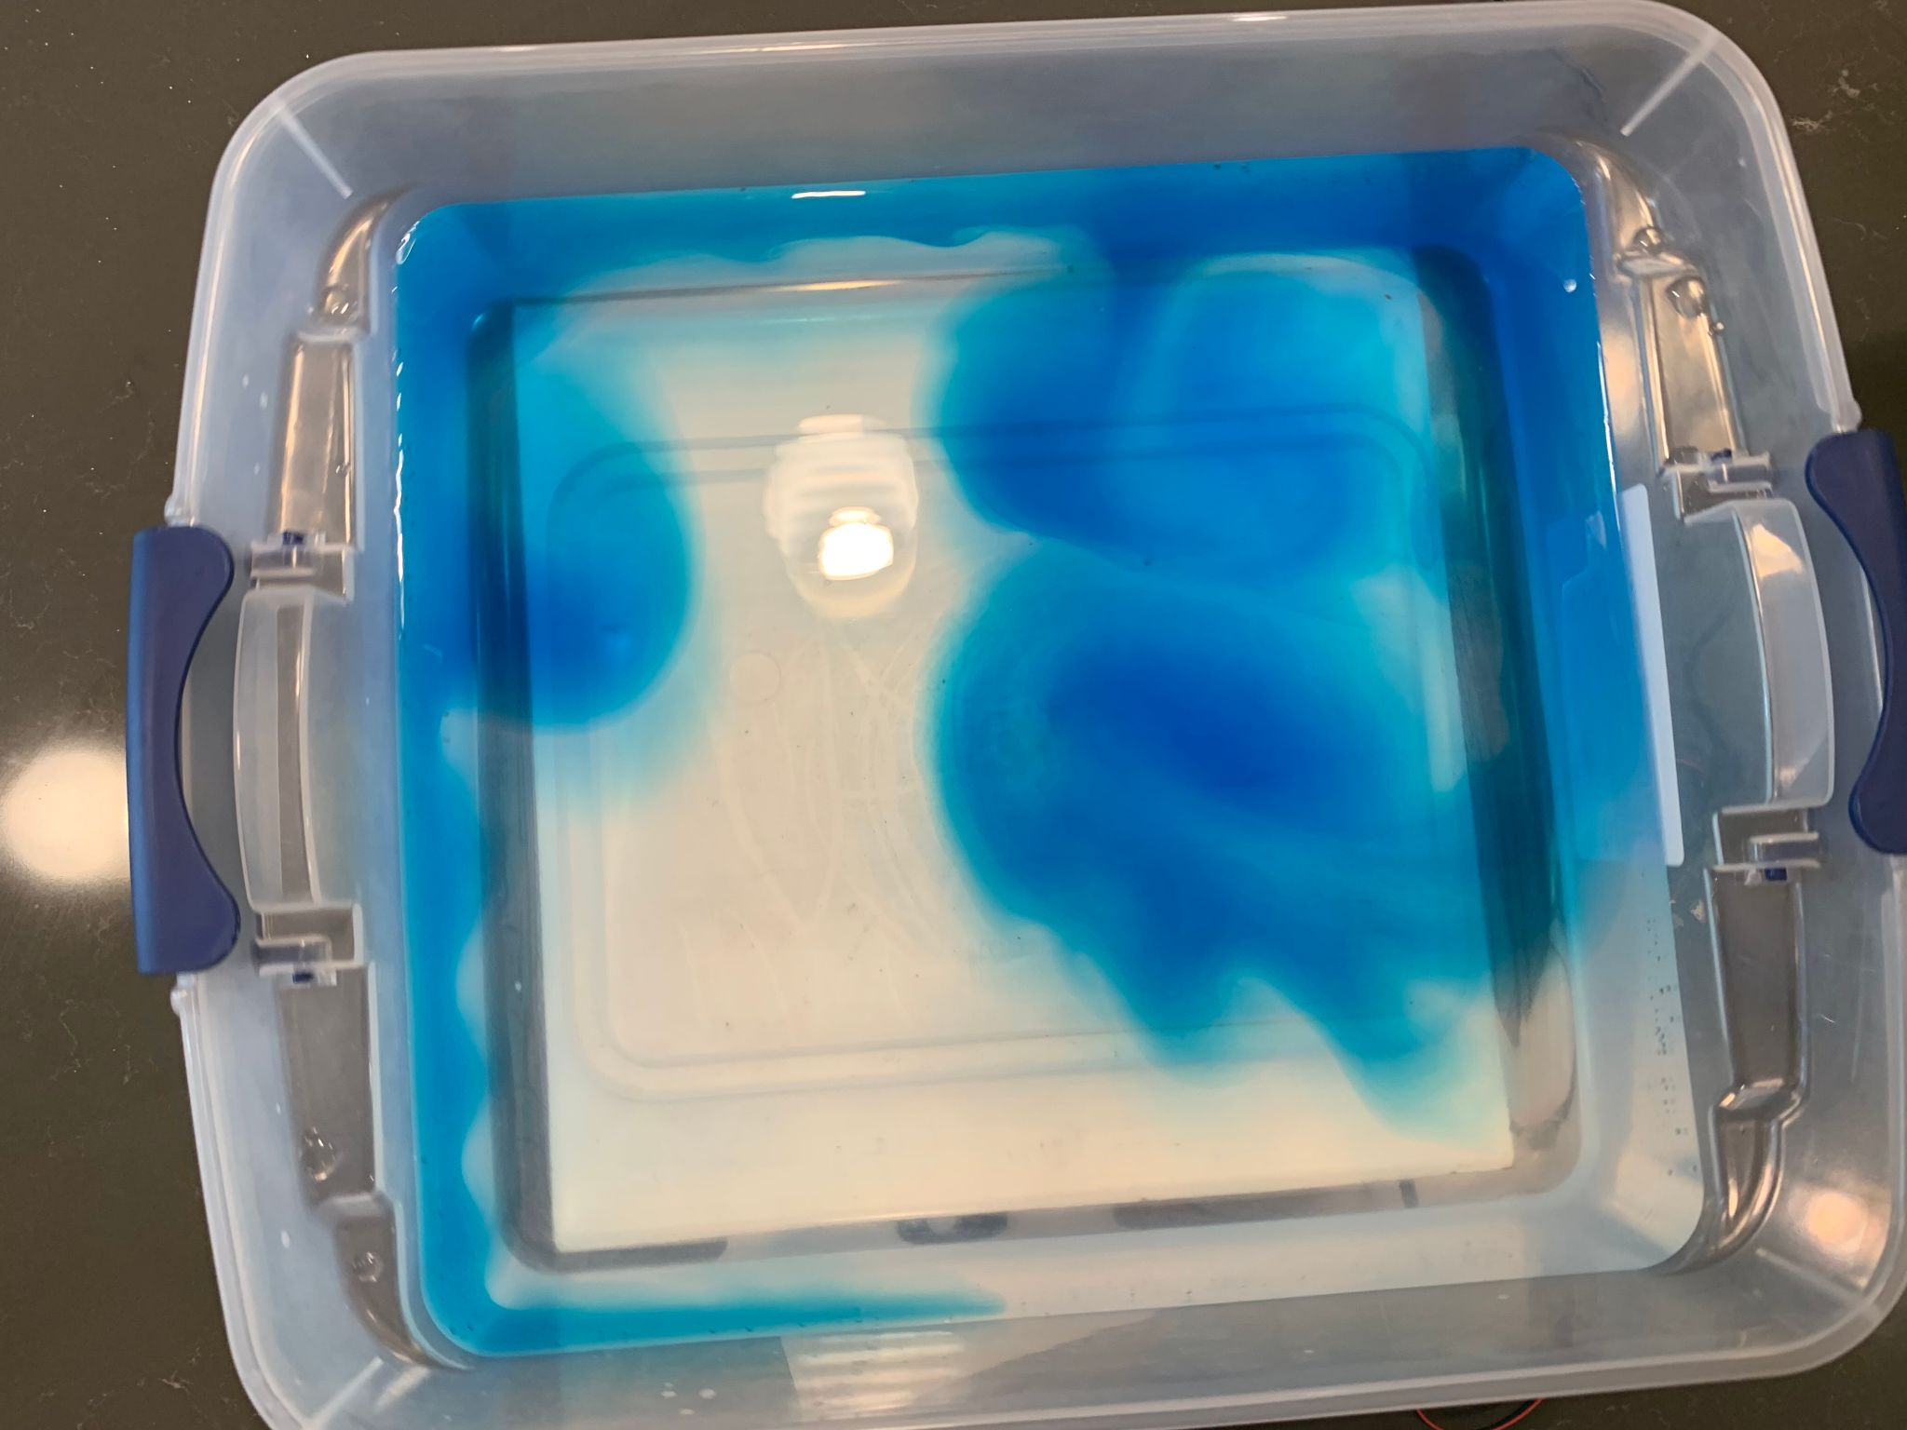

**Figure 4 & 5**. Example of a surface advected plume using the wavetable. The blue water is the non-saline solution, sitting above the clear ocean water.

In conclusion, the defining factors leading to the different types of plumes are the coastal shelf currents and the depth of the seafloor surrounding the estuary.

1. **Once solid body rotation has been achieved, repeat step 3 and pour the rest of your colored, NON SALT water solution into one corner of the tank.**

Has the shape of this plume differed from the previous one? How has it changed?

|  |
| --- |

Why has it changed, and how might you manipulate the variables in this experiment further, in order to produce different results?

| **Changing variable** | **Observations on how it changed the system** |
| --- | --- |
| Speed |  |
| Depth |  |
| Write your own: _______________ |  |
| Write your own: _______________ |  |
| *General notes:* |  |

**Examples**

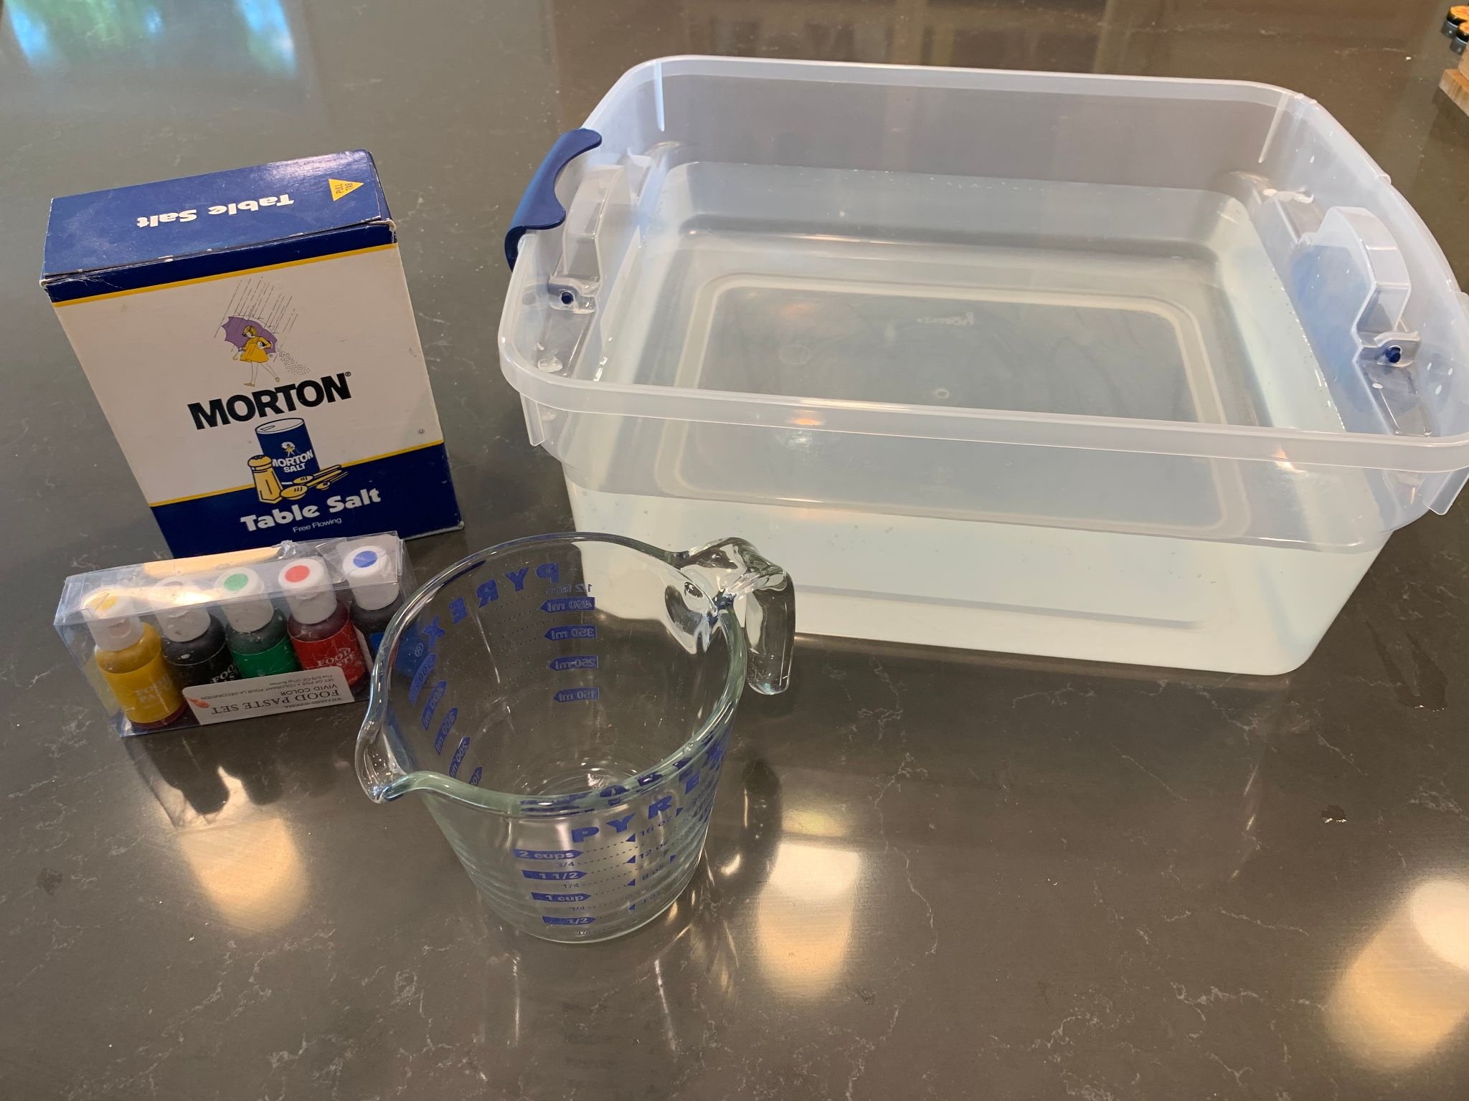

**Figure 6.** Materials needed

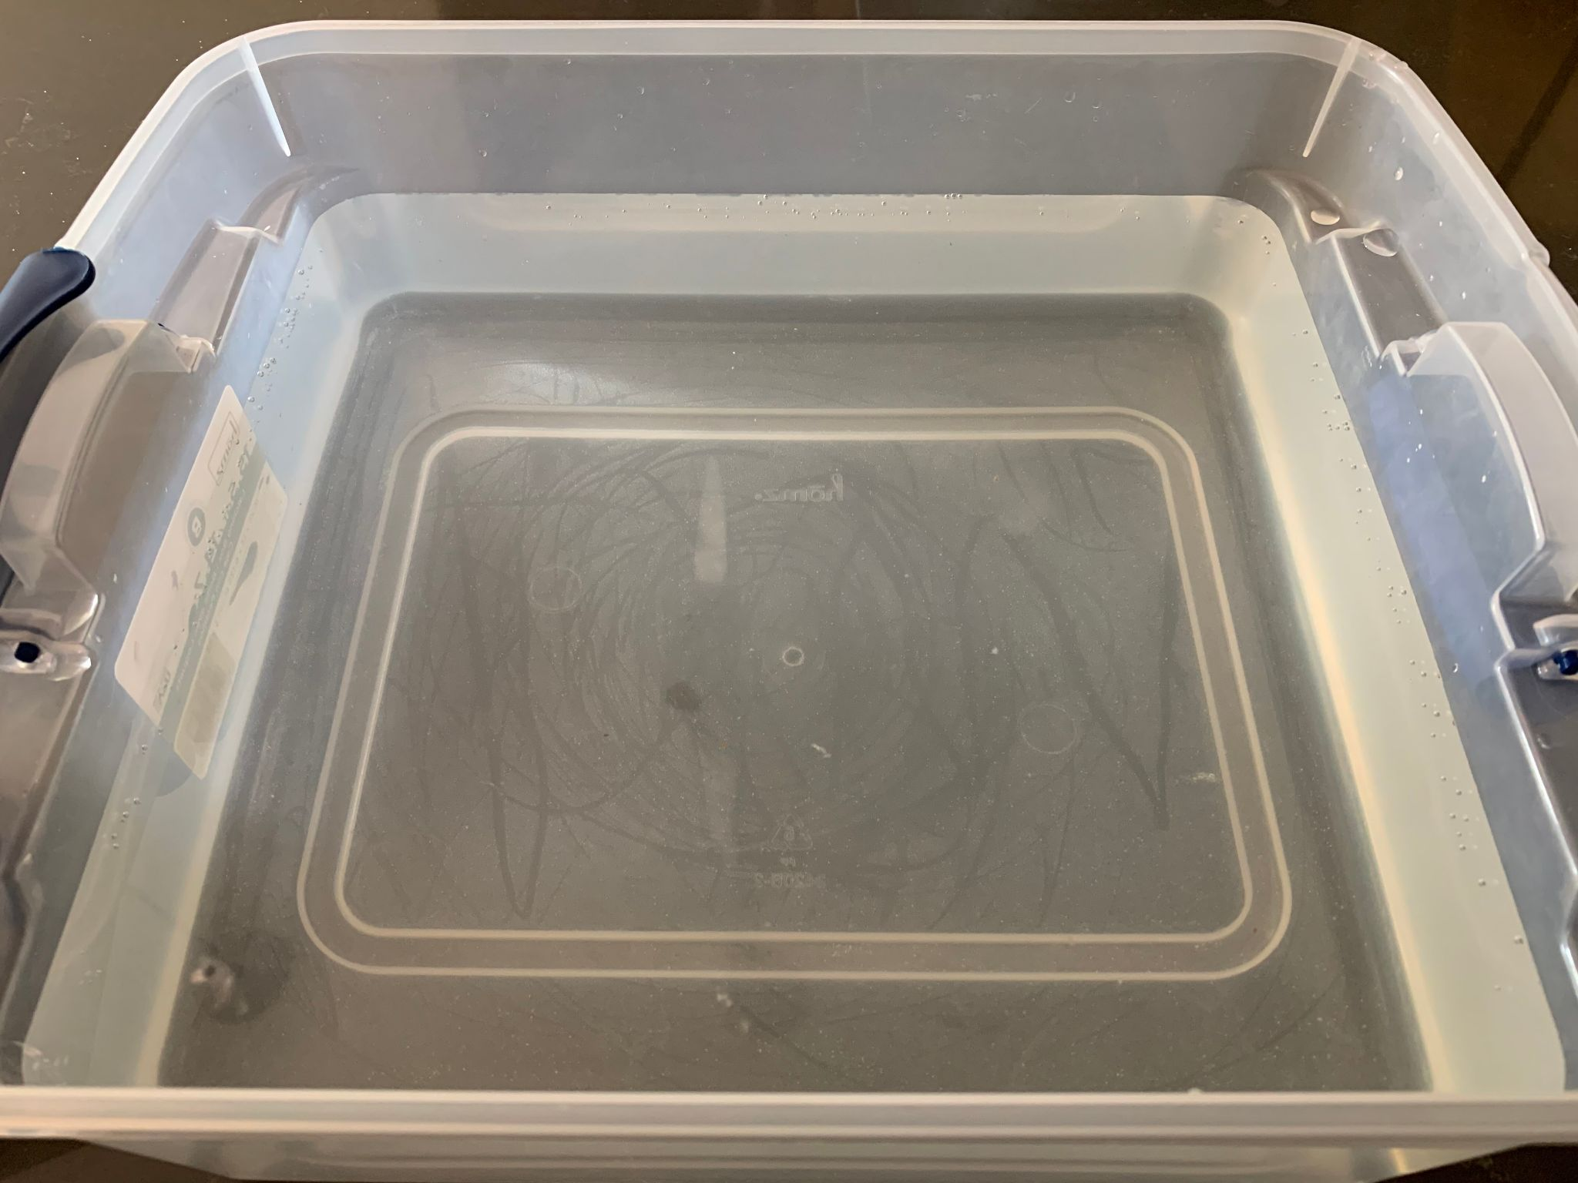

**Figure 7.** Optimal water fill height

**Bibliography**

1. <https://www.iybssd2022.org/en/the-plume-of-the-amazon-regains-its-tides/>
2. <https://www.researchgate.net/publication/326782148_The_hyperpycnite_problem>
3. <https://journals.ametsoc.org/view/journals/phoc/27/7/1520-0485_1997_027_1386_astftf_2.0.co_2.xml?tab_body=pdf>

**Appendix**

**A.**

From the *Journal of Paleobiology*, this is a quick table showing the 12 types of river plumes.

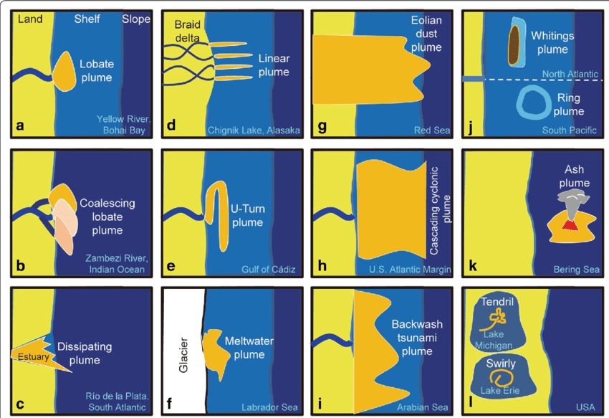

**Fig 4.** [2]

1. For a comprehensive list, see appendix A